BRAIN TUMOR CLASSIFICATION USING DEEP LEARNING ALGORITHMS

N.PRASANNA

ME CSE, Saranathan College of Engineering, Tiruchippalli

Email:prasannananda18@gmail.com,
Contact:7418849490

Abstract:. Brain tumors are a significant health concern, and early detection is crucial for effective treatment. This study explores the application of deep learning models, specifically VGG-16, Inception v3, ResNet-50, and Deep Belief Networks (DBNs), for the classification of brain tumors using MRI images. Each model's architecture is tailored to extract and learn complex features from the images, enabling accurate classification. The performance of these models is evaluated based on metrics such as accuracy, precision, recall, and F1-score. The results demonstrate the potential of deep learning in enhancing the accuracy and efficiency of brain tumor detection, providing a valuable tool for medical professionals in diagnosing and treating brain tumors. Transfer learning techniques are incorporated into each algorithm, utilizing pre-trained models on large image datasets to enhance adaptability and generalization to novel data. As the field of medical image analysis continues to advance, the utilization of the Deep Learning algorithms in Brain tumor classification exemplifies a multifaceted approach towards achieving efficient and accurate diagnosis, ultimately benefiting both healthcare practitioners and patients. The Deep Learning models proposed in this paper offer superior performance in complex Brain tumor classification tasks and outperform Machine Learning models.

- INTRODUCTION

A brain tumor occurs when abnormal cells form within the brain. There are two main types of tumors: malignant (cancerous) tumor and benign (non- cancerous) tumors. These can be further classified as primary tumors, which start tumors located outside the brain, known as brain metastasis tumors. All types of brain tumors may produce symptoms that vary depending on the size of the tumor and the part of the brain that is involved. Where symptoms exist, the may include headaches, seizures, problems with vision, vomiting and mental changes, other symptoms may include difficulty walking speaking, with sensations, or unconsciousness.
Treatment may include some combination of surgery, radiation therapy and chemotherapy.] If seizures occur, anticonvulsant medication may be needed. Dexamethasone and furosemide are medications that may be used to decrease swelling around the tumor. Some tumors grow gradually, requiring only monitoring and possibly needing no further intervention. Treatments that use a person's immune system are being studied. Outcomes for malignant tumors vary considerably depending on the type of tumor and how far it has spread at diagnosis.
Deep learning models, like Convolutional Neural Networks (CNNs), have shown remarkable accuracy in identifying and classifying brain tumors from MRI scans. They can detect subtle patterns and anomalies that might be missed by human eyes, leading to more precise and early diagnoses.
Deep learning can process large volumes of imaging data quickly, which speeds up the diagnostic process. This automation reduces the workload on radiologists and allows them to focus on more complex cases.
Deep learning can integrate imaging data with other types of data, such as genomic information, to provide a comprehensive view of the tumor. This integration leads to better diagnosis and treatment strategies.
Overall, deep learning enhances the accuracy, efficiency, and consistency of brain tumor detection and treatment, ultimately leading to better patient care and outcomes. It's a game-changer in the medical field, providing tools and insights that were previously unattainable.

- IDEINTIFICATION OF BRAIN TUMOR TECHENIQUES

This paper investigates the use of multi-model deep learning to enhance survival predictions for pediatric brain tumor patients by integrating imaging data (Whole slide images) and genomic data (gene expression). It highlights the shortcomings of traditional single-source data approaches in accurately forecasting patient outcomes. The study also emphasizes the need for interpretability in predictive models, proposing pathway analysis as a method to understand the underlying biological mechanism, and suggests the future research should be explore incorporation more diverse data types to improve prediction accuracy.
Data Fusion Techniques: It utilizes early and late fusion strategies to combine imaging and genomic data, with early fusion showing the best performance in experiments.
Grid Search for Learning Rates: A grid search is conducted to optimize learning rates for each data modality, ensuring that the model learns effectively from both histopathology and genomic data.
Joint Training Approach: A complex multimodal framework is implemented where both modalities are learned simultaneously, using different learning rates for histopathology and genomic data to balance their learning speeds.
Deep Learning Model: Specifically, it employs deep neural network(DNNs) to process and analyze the combined data from imaging and genomic sources, enhancing the model’s ability to capture complex patterns in the data.
Transfer Learning: The study lee rages transfer learning apply knowledge gained from a pediatric glioma cohort to predict outcomes in other pediatric brain tumor types, such as ependymoma and medulloblastoma, which have smaller sample sizes.
Cox Proportional Hazards Model: The research integrates traditional survival analysis methods, like the Cox proportional hazards model, with deep learning architectures to improve prognosis prediction on censored data.
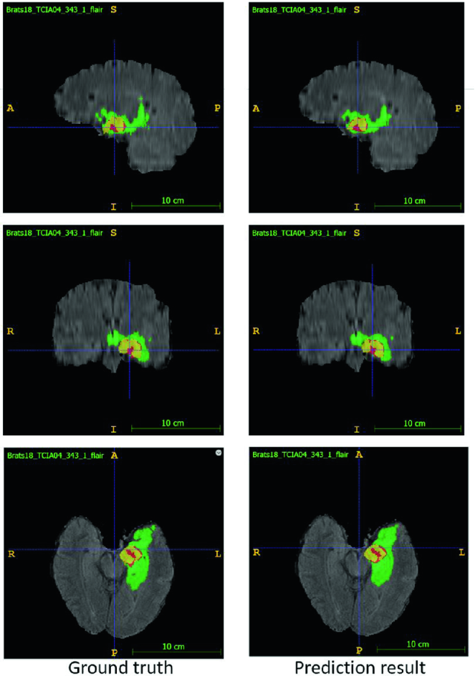
Figure 1: Survival Prediction Result
Performance metrics

Alogrithm Accuracy F1-Score

VGG 16 88 91
Incepetion v3 95 99
RESNET-50 94 91

- IMPLEMENTATION OF VGG-16 FOR BRAIN TUMOR

Preprocessing images is a crucial step for enhancing the accuracy of MRI-based brain tumor classification. Here are some insights into the preprocessing techniques typically used:
- Normalization: Adjusting the intensity values of the MRI images to a common scale. This helps in reducing variations caused by different imaging settings or patient conditions.
- Resizing: Ensuring that all images have the same dimensions so they can be fed into the neural network models like ResNet50, Inception V3, and VGG16.
- Data Augmentation: Applying transformations like rotation, flipping, and zooming to create a diverse set of training images. This helps in improving the generalization capability of the model.
- Segmentation: Isolating the region of interest (ROI) from the rest of the image. For brain tumors, this often involves extracting the tumor region from the MRI scan.
- Denoising: Removing noise from the MRI images using filters to improve the quality of the input data.
- Histogram Equalization: Enhancing the contrast of the images to highlight important features.

  - IMPLEMENTATION OF INCEEPTION V3 FOR BRAIN TUMOR

Inception V3 is a powerful convolutional neural network (CNN) architecture that can be very effective for brain tumor classification. Here are some reasons why it's helpful:
- Feature Extraction: Inception V3 is designed to extract features at multiple scales using its inception modules. This allows it to capture both local and global features from MRI images, which is crucial for identifying different types of brain tumors.
- Transfer Learning: You can use pre-trained Inception V3 models that have been trained on large datasets like ImageNet. This helps in leveraging learned features and reduces the need for extensive training data, making it easier to achieve high accuracy with fewer images.
- Efficiency: Despite its depth and complexity, Inception V3 is computationally efficient due to its optimized architecture. This makes it suitable for processing large volumes of medical imaging data.
- High Accuracy: Studies have shown that Inception V3, when fine-tuned for specific tasks like brain tumor classification, can achieve high accuracy rates. This is particularly important in medical applications where precision is critical.
- Multi-Modal Data Integration: Inception V3 can be combined with other models (like Xception in a dual-channel CNN) to further enhance classification performance. This integration allows for better feature representation and improved diagnostic precision.
  - IMPLEMENTATION OF RESNET 50 FOR BRAIN TUMOR
ResNet50 can be very effective for brain tumor classification! Here are some reasons why it works well:
- Deep Architecture: ResNet50 is a deep convolutional neural network with 50 layers, which allows it to learn complex features from MRI images.
- Residual Learning: The residual learning framework helps in training deeper networks by addressing the vanishing gradient problem, making it easier to optimize the network.
- High Accuracy: Studies have shown that ResNet50 can achieve high accuracy rates in classifying brain tumors. For example, one study reported an accuracy of 99.03% using ResNet50 for multi-class brain tumor classification2.
- Transfer Learning: You can use pre-trained ResNet50 models that have been trained on large datasets like ImageNet, which can be fine-tuned for your specific task of brain tumor classification.
- Multi-Class Classification: ResNet50 can handle multi-class classification problems, making it suitable for distinguishing between different types of brain tumors such as glioma, meningioma, and pituitary tumors.
  - IMPLEMENTATION IN DEEP BLIEF ALGORITHMS
Implementing Deep Belief Networks (DBNs) for brain tumor classification involves several key steps.
- Preprocessing: This step involves preparing the MRI images for analysis. Techniques like normalization, resizing, and denoising are applied to enhance image quality and consistency.
- Segmentation: The tumor region is isolated from the rest of the brain image. This can be done using methods like thresholding, region growing, or edge detection.
- Feature Extraction: Features are extracted from the segmented images. Common techniques include using Discrete Wavelet Transform (DWT) to capture texture and shape features.
- Training the DBN: The extracted features are used to train the Deep Belief Network. DBNs are trained in a layer-wise manner, where each layer learns to represent the data more abstractly1.
- Classification: The trained DBN is used to classify the brain tumors into different categories (e.g., benign or malignant). The network makes predictions based on the learned features and the error function is minimized during training1.
- Evaluation: The performance of the DBN is evaluated using metrics like accuracy, sensitivity, and specificity. This helps in understanding the effectiveness of the model in classifying brain tumors.
  - DFKZ Net:
The fig 3.3.3 explains the architecture second network we employ is DFKZ Net, which was proposed by Isensee et al. from German Cancer Research Center (DFKZ). This network is inspired by U-Net. It employs a context encoding pathway that extracts increasingly abstract representations of the input, and a decoding pathway used to recombine these representations with shallower features to precisely segment the structure of interest. The context encoding pathway consists of three content modules, each has two 3×3×3 convolutional layers and a dropout layer with residual connection. The decoding pathway consists of three localization modules, each contains a 3×3×3 convolutional layer followed by a 1×1×1 convolutional layer. For the decoding pathway, the output of layers of different depth is integrated by elementwise summation, thus the supervision can be injected deep in the network.

3D U-Net:
U-Net [5, 14] is a classical network for biomedical image segmentation. It consists of a contracting path to capture context and a symmetric expanding path that enables precise localization with extension. Each pathway has three convolutional layers with dropout and pooling. And the contracting pathway and expanding pathway are linked by skip-connections. Each layer contains 3×3×3 convolutional kernels. The first convolutional layer has 32 filters, while deeper layers contains twice filters than previous shallower layer.

$$L=-\frac{2}{|K|}=\sum_{k∈K}{\frac{\sum_{i}{u_{i(k)}v_{i(k)}}}{\sum_{i}{u_{i(k)}}+\sum_{i}{v_{i(k)}}}}$$

  - WORKING PROCESS OF DBN IN BRAIN TUMOR
Applications: DBNs have been applied in various fields, including image recognition, speech recognition, and natural language processing.
A deep belief net can be viewed as a composition of simple learning modules each of which is a restricted type of Boltzmann machine that contains a layer of visible units that represent the data and a layer of hidden units that learn to represent features that capture higher-order correlations in the data. The two layers are connected by a matrix of symmetrically weighted connections, W , and there are no connections within a layer. Given a vector of activities v for the visible units, the hidden units are all conditionally independent so it is easy to sample a vector, h , from the factorial posterior distribution over hidden vectors, p(h|v,W) . It is also easy to sample from p(v|h,W) . By starting with an observed data vector on the visible units and alternating several times between sampling from p(h|v,W) and p(v|h,W) , it is easy to get a learning signal. This signal is simply the difference between the pairwise correlations of the visible and hidden units at the beginning and end of the sampling.The key idea behind deep belief nets is that the weights, W , learned by a restricted Boltzmann machine define both p(v|h,W) and the prior distribution over hidden vectors, p(h|W) , so the probability of generating a visible vector, v
can be written as:

$$p\left(v\right)=\sum_{h}{p\left(h | W\right)p(v|h,W)}$$

After learning W , we keep p(v|h,W) but we replace p(h|W) by a better model of the aggregated posterior distribution over hidden vectors – i.e. the non-factorial distribution produced by averaging the factorial posterior distributions produced by the individual data vectors. The better model is learned by treating the hidden activity vectors produced from the training data as the training data for the next learning module.

PERFORMANCE METRICS
ALGORITHM | ACCURACY | PRECISION | RECALL | F1-SCORE
VGG-16 | 80-88% | 96% | 91% | 91.78%
INCEPTION V3 | 94.34% | 98% | 98% | 98.52%
ResNet-50 | 94% | 96% | 92.6% | 91.29

SNO | TRUE | FALSE
1. | 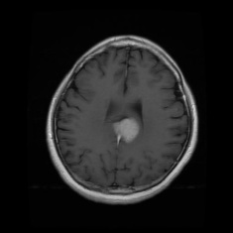 | 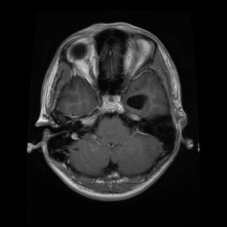
2. | 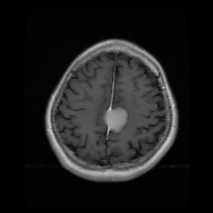 | 

CONFUSION INCEPTION V3 ALGORITHM
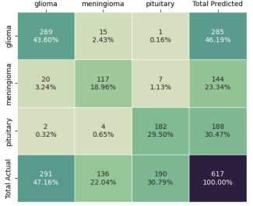

Summary
In our journey through deep learning and its application to brain tumor detection, we've explored several advanced architectures, including Inception v3, VGG-16, ResNet-50, and Deep Belief Networks (DBNs). Each of these models has unique features that make them suitable for complex tasks like medical imaging.
- Inception v3: Known for its Inception modules and factorized convolutions, it captures various levels of features efficiently.
- VGG-16: Simple yet powerful, with a consistent use of 3x3 convolutions, it excels in deep feature extraction.
- ResNet-50: Utilizes residual blocks to overcome vanishing gradients, allowing for deeper networks.
- Deep Belief Networks (DBNs): Generative models that learn features layer by layer using Restricted Boltzmann Machines (RBMs).The proposed system design for brain tumor detection includes steps such as data collection, preprocessing, model training, evaluation, and deployment. Each step ensures the system is accurate, efficient, and robust.

Future Work
- Enhanced Data Augmentation: Implementing more sophisticated data augmentation techniques can help in creating a more diverse dataset, which can improve model generalization.
- Multi-Modal Data Integration: Integrating different types of data (e.g., MRI, genetic data, clinical records) can provide a comprehensive understanding of brain tumors, leading to better predictions.
- Transfer Learning: Using pre-trained models on large medical datasets and fine-tuning them for specific tasks can save time and resources while improving performance.
Output:
VGG -16 Classification Results:
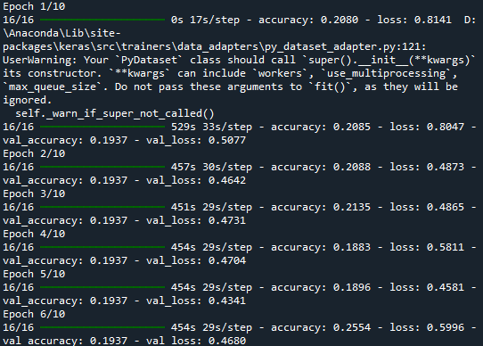
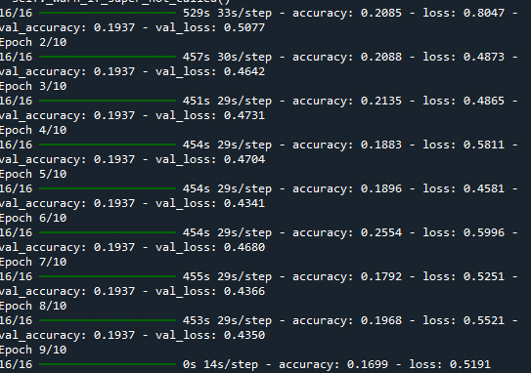
Inception v3 Classifications Results :
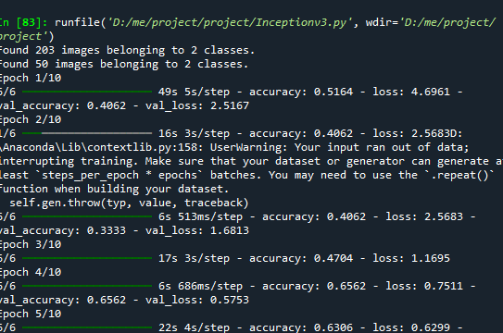
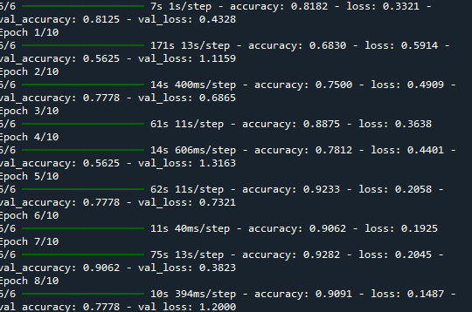
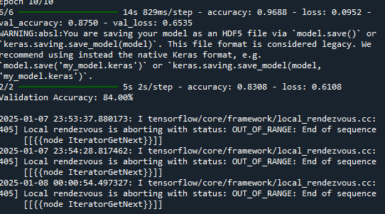

Resnet 50 classification Results:

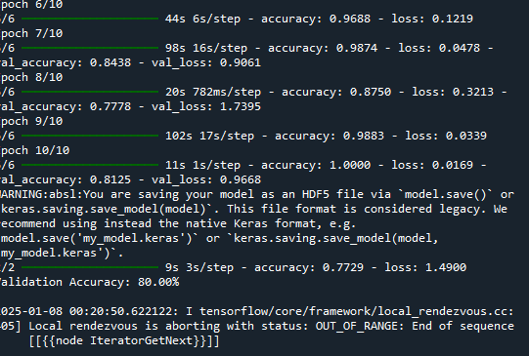
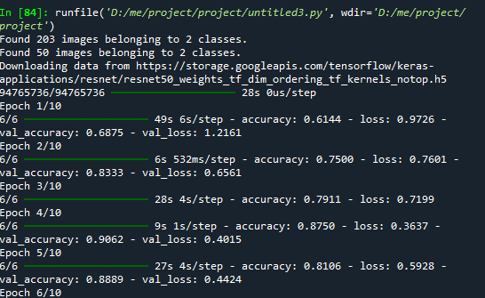
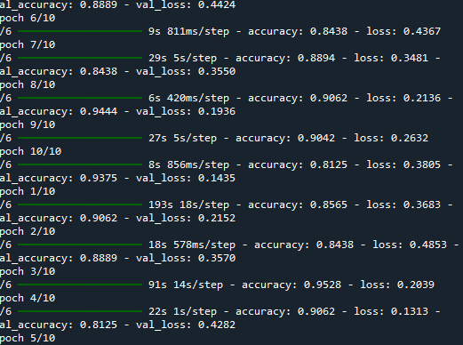

REFERENCES

- Sandra Steyaert, Yeping Lina Qiu Yuanning Zhen, Pritam Mukherjee, Hannes Vogel and Olivier Gevaert --Multimodal data fusion of adult and pediatric brain tumors with deep learning.
- Arshia Rehman, Saeeda Naz, Muhammad Imran Razzak, Faiza Akram, Muhammad Imran - A Deep Learning-Based Framework for Automatic Brain Tumors Classification Using Transfer Learning
- Neelum Noreen, Sellappan Palaniappan, Abdul Qayyum , Iftikhar Ahmad, Muhammad Imran, And Muhammad Shoaib, -- A Deep Learning Model Based on Concatenation Approach for the Diagnosis of Brain Tumor.
- Ahmet Çinar, Muhammed Yildirim -- Detection of tumors on brain MRI images using the hybrid convolutional neural network architecture.
- Soheila Saeedi, Sorayya Rezayi, Hamidreza Keshavarz, and Sharareh R. Niakan Kalhori, -- MRI-based brain tumor detection using convolutional deep learning methods and chosen machine learning techniques.
- Md Ishtyaq Mahmud, Muntasir Mamun and Ahmed Abdelgawad,-- A Deep Analysis of Brain Tumor Detection from MR Images Using Deep Learning Networks.
- Sandra Steyaert, Yeping Lina Qiu, Yuanning Zheng, Pritam Mukherjee, Hannes Vogel3 & Olivier Gevaert -- Multimodal deep learning to predict prognosis in adult and pediatric brain tumors.
- Arshia Rehman, Saeeda Naz, Muhammad Imran Razzak, Faiza Akram, Muhammad Imran, -- A Deep Learning-Based Framework for Automatic Brain Tumors Classification Using Transfer Learning
- Ayesha Younis, Qiang Li, Zargaam Afzal, Mohammed Jajere Adamu,Halima Bello Kawuwa, Fida Hussain And Hamid Hussain, Abnormal Brain Tumors Classification Using ResNet50 and Its Comprehensive Evaluation.

